**Filtering Noisy Audio**

**Project Report**



**Spring 2023**

**CSE301L Signals & Systems Lab**

Submitted by:

**Shahzad Bangash(21PWCSE1980),**

**Suleman Shah(21PWCSE1983),**

**Ali Asghar(21PWCSE2059)**

Class Section: **C**

“On my honor, as student of University of Engineering and Technology, I have neither given nor received unauthorized assistance on this academic work.”

Submitted to:

**Engr. Sumayyea Salahuddin**

Date:

**June 28, 2023**

**Department of Computer Systems Engineering**

**University of Engineering and Technology, Peshawar**

**Problem Statement:**

The problem addressed in this project is the presence of noise in an audio signal, which degrades the audio quality and affects the listening experience. The goal is to apply filtering techniques to remove or reduce the noise from the audio signal and enhance its quality.

**Introduction:**

The project aims to analyze and process a noisy audio signal using filtering techniques. By designing and implementing filters, calculating impulse responses, and performing convolution, the project aims to attenuate the unwanted noise and improve the overall audio quality. The study involves exploring the frequency characteristics of the signal, designing filters, analyzing their frequency response, and evaluating the filtered audio outputs.

**Methodology:**

The project methodology comprises the following steps:

**Code Screenshots:**

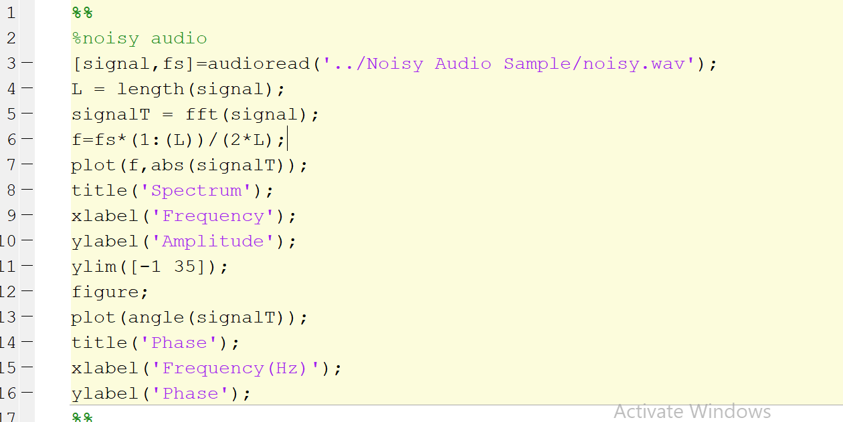

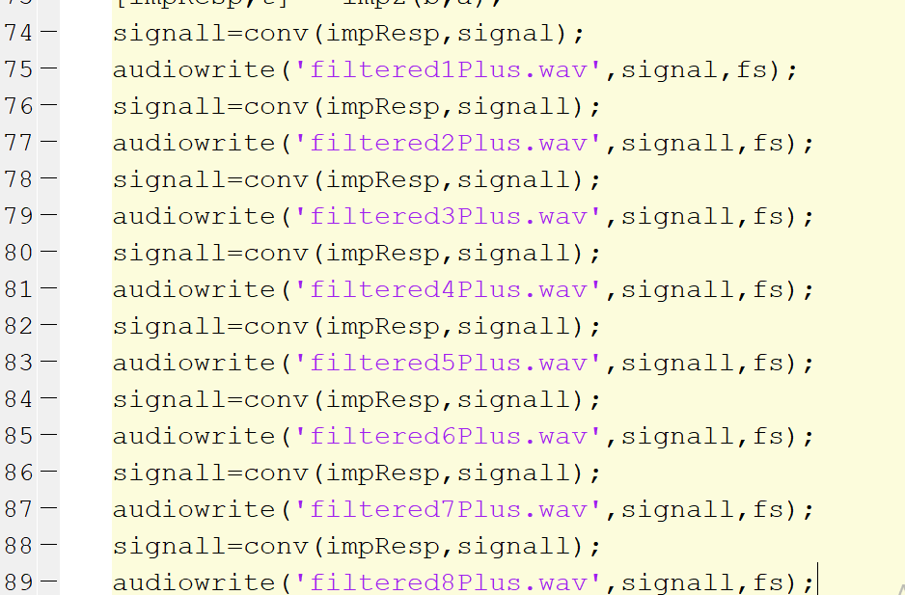

**Code Explanation:**

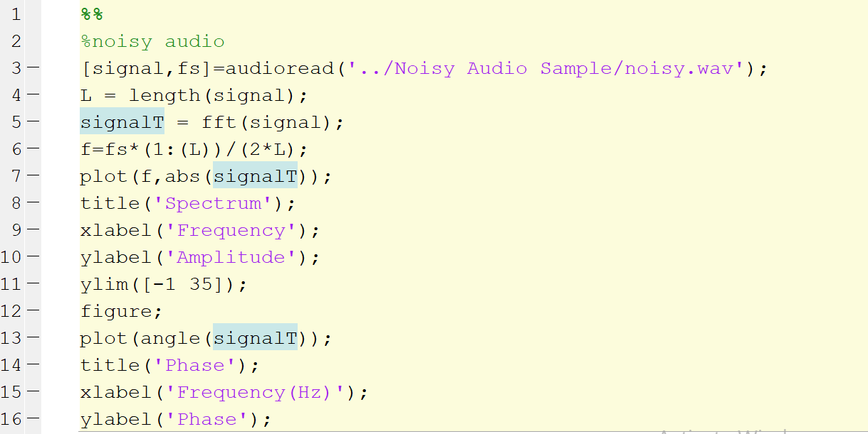

This part of the code reads an audio file named "noisy.wav" and stores the signal in the variable signal and the sampling frequency in fs. It then performs a Fast Fourier Transform (FFT) on the signal to obtain its frequency spectrum and plots the magnitude spectrum (abs(signalT)) against the corresponding frequencies (f). It also plots the phase spectrum (angle(signalT)) against the frequencies. The resulting plots show the frequency content and phase information of the noisy audio signal.

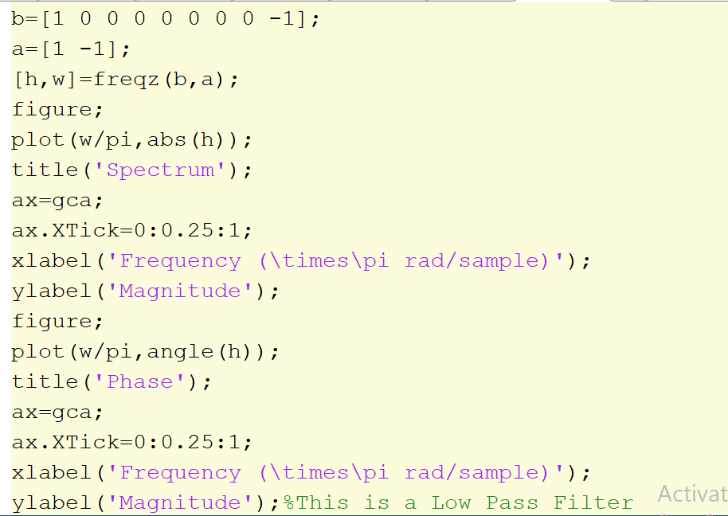

This section defines a system function for a filter with coefficients b and a. It then uses the freqz function to compute the frequency response of the filter and plots the magnitude spectrum (abs(h)) and phase spectrum (angle(h)) against the normalized frequencies (w/pi). The resulting plots show the frequency response (magnitude and phase) of the filter.

These lines of code visualize the poles and zeros of the filter using the fvtool function. The eqtflength function is used to equalize the lengths of the numerator (b) and denominator (a) coefficients, and tf2zp function is then used to obtain the pole-zero representation of the filter.

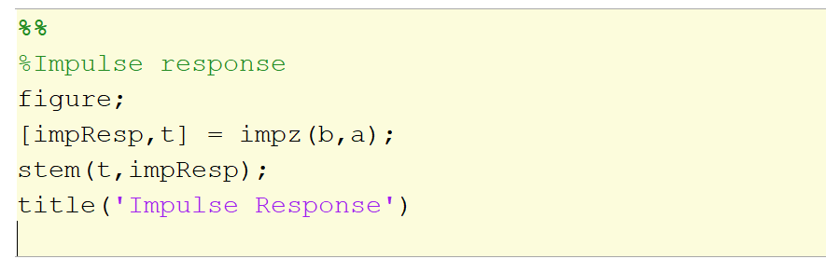

This part calculates the impulse response of the filter using the impz function and plots it using stem. The impulse response represents the output of the filter when an impulse is applied as the input.

In this section, the original audio signal is filtered using the impulse response of the initial filter. The conv function performs the convolution of the impulse response (impResp) with the signal. The resulting filtered signal is then saved as audio files (filtered1.wav, filtered2.wav, ..., filtered8.wav) using the audiowrite function. Each iteration of the convolution applies the filter to the previously filtered signal, resulting in a progressively filtered output.

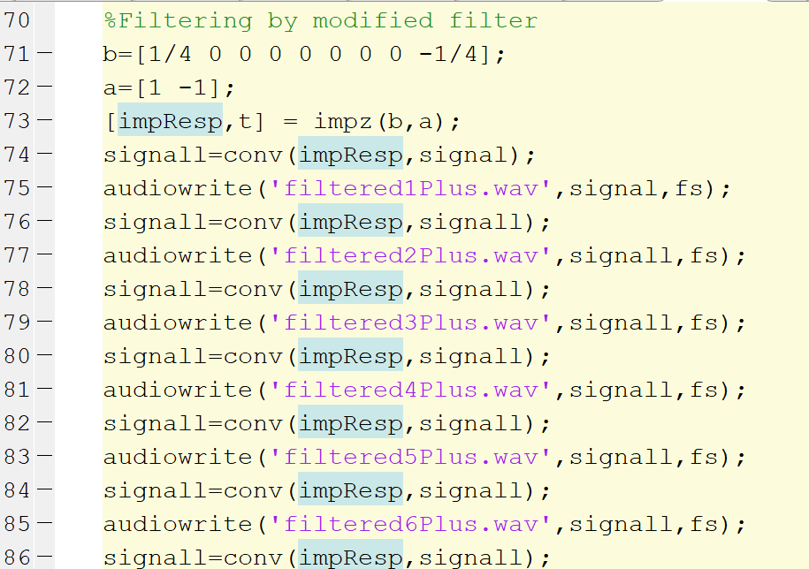

This last section performs a similar process as before, but with a modified filter. The filter coefficients are changed to [1/4 0 0 0 0 0 0 0 -1/4]. The impulse response of the modified filter is calculated, and the original signal is filtered using this modified filter. The filtered signals are saved as audio files (filtered1Plus.wav, filtered2Plus.wav, ..., filtered8Plus.wav).

**Flow of Program:**

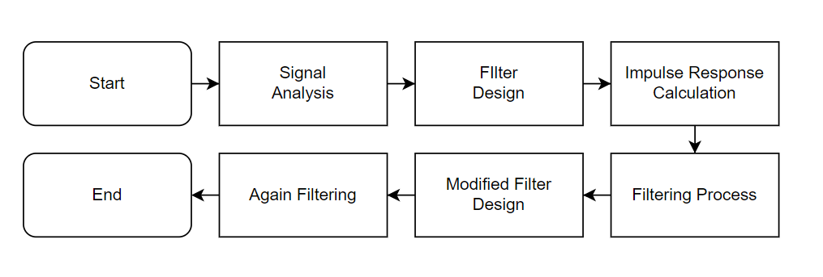

**Step 1: Signal Analysis:**

* Read the noisy audio signal and extract its sampling frequency.
* Apply the Fast Fourier Transform (FFT) to analyze the frequency content and phase information of the signal.
* Visualize the magnitude spectrum and phase spectrum of the signal.

**Step 2: Filter Design:**

* Design an initial filter by specifying the filter coefficients.
* Compute the frequency response of the initial filter using the `freqz` function.
* Plot the magnitude and phase spectra of the filter's frequency response.
* Visualize the poles and zeros of the filter using the `fvtool` function.

**Step 3: Impulse Response Calculation:**

* Calculate the impulse response of the initial filter using the `impz` function.
* Plot the impulse response to analyze its characteristics and determine its length.

**Step 4: Filtering Process:**

* Filter the original noisy signal using the calculated impulse response of the initial filter.
* Save the filtered signals as separate audio files using the `audiowrite` function.
* Repeat the filtering process iteratively, convolving the impulse response with the previously filtered signal.

**Step 5: Modified Filter Design and Filtering:**

* Modify the filter coefficients to create a modified filter.
* Calculate the impulse response of the modified filter.
* Filter the original signal using the modified filter.
* Save the filtered signals as separate audio files.

**04. Results:**

The project yields the following results:

* + Frequency spectra and phase spectra of the original noisy audio signal.
  + Frequency response of the initial filter, including magnitude and phase spectra.
  + Impulse response of the initial and modified filters.
  + Filtered audio signals at different stages of filtering.

**Conclusion:**

The project demonstrates the effectiveness of filtering techniques in reducing noise and improving the audio quality of a noisy signal. The analysis of frequency spectra, filter characteristics, and impulse responses provides valuable insights into the signal processing methods used. The comparison between the results obtained from the initial filter and the modified filter allows for evaluating the performance and impact of different filter designs. Overall, the project highlights the significance of audio filtering techniques in enhancing the quality of audio signals.

**References:**

Provide a list of references used during the project, including textbooks, research papers, online resources, and any relevant documentation.

This revised project report follows the requested structure, presenting the problem statement, introduction, methodology, results, conclusion, and references. The report provides a comprehensive overview of the project, its objectives, the applied methodology, obtained results, and the significance of the findings.